**BACKGROUND:**

* This research project is to test whether the gender of a virtual conversational agent on a fintech platform will have any effect on user experience.
* The gender of a virtual conversational agent can be expressed in 2 ways: the appearance of the avatar and the communication style of the chat.
* This research project is interested in testing both aspects.
* To test both aspects, the project will be split into 2 studies: Study 1 and Study 2. Study 1 and Study 2 are done with separate groups of participants.
* Study 1 and Study 2 follows the same flow, but there will be different number of conditions and different scripts to flow. Detailed descriptions of Study 1 and Study 2 provided below.

**STUDY 1:**

***Overview:***

Study 1 is only concerned with testing the effects of the appearance of the virtual agent and seeing if the effects will interact with the gender of the user.

Hence, Study 1 has **four** experimental conditions:

|  |  |  |
| --- | --- | --- |
|  | User gender: Female | User gender: Male |
| Agent gender: Female | ***Condition 1*** | ***Condition 2*** |
| Agent gender: Male | ***Condition 3*** | ***Condition 4*** |

*All in all, programmers only need to know that there will be* ***2 kinds of pages needed (1. female agent and 2. male agent).*** *Programmers do not need to care about the variation in user gender because experimenters will manually allocate research participants to the correct conditions.*

***Flow of experiment****: The whole experiment consists of participants chatting with the virtual agent. Over the course of the conversation, participants will engage in three tasks with the virtual agent (choosing bank account, choosing home loan plan and choosing insurance plan).**After the completion of each task, participants will be click “Next” to a page to answer some questions (same as Yihan’s project). Upon completion of the short survey, participants will click “Next” to resume the conversation. Please refer to the Script document for the questions*

Breakdown of steps:

1. Participants will first view a short introduction page about the virtual agent (new update from Cui Min).
2. Participants will then start chat with the virtual agent. (Steps 2, 3 & 4 are repeated, only the task within each step changes)
   1. The chat will lead to the virtual agent helping the participant to choose a bank account.
   2. After the bank account recommendation is given, participants will click “Next” to do a survey.
   3. Upon completion of the survey, participants will click “Next” to resume with chat.
3. Participants will then resume chat with the virtual agent.
   1. The chat will lead to the virtual agent helping the participant to choose a home loan plan.
   2. After the home loan plan recommendation is given, participants will click “Next” to do a survey.
   3. Upon completion of the survey, participants will click “Next” to resume with chat.
4. Participants will then resume chat with the virtual agent.
   1. The chat will lead to the virtual agent helping the participant to choose an insurance plan.
   2. After the insurance plan recommendation is given, participants will click “Next” to do a survey.
5. End of experiment.

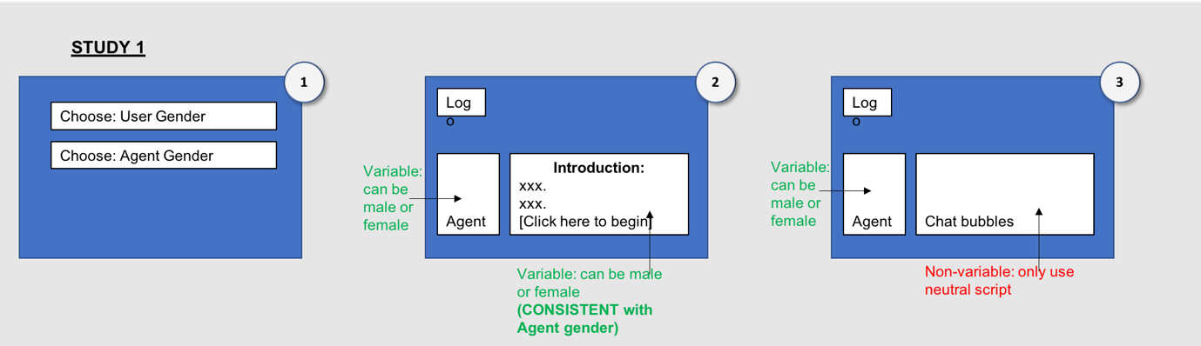

Figure: Diagram to represent flow of Study 1

**STUDY 2:**

***Overview:***

Study 2 is the same as Study 1, except now there is a third variable: communication style.

Hence, Study 1 has **eight** - 2 (user gender) * 2 (agent gender) * 2 (communication style) - experimental conditions:

|  |  |  |  |
| --- | --- | --- | --- |
| Female communication style |  | User gender: Female | User gender: Male |
| Agent gender: Female | ***Condition 1*** | ***Condition 2*** |
| Agent gender: Male | ***Condition 3*** | ***Condition 4*** |
|  | | | |
| Male communication style |  | User gender: Female | User gender: Male |
| Agent gender: Female | ***Condition 5*** | ***Condition 6*** |
| Agent gender: Male | ***Condition 7*** | ***Condition 8*** |

*All in all, programmers only need to know that there will be* ***4 kinds of pages needed (1. female agent with female communication style; 2. female agent with male communication style; 3. Male agent with female communication style; 4. Male agent with male communication style).*** *Programmers do not need to care about the variation in user gender because experimenters will manually allocate research participants to the correct conditions.*

***Flow of experiment****: The flow of experiment is the same as study 1. The only difference is that the script will be different (refer to script document).*

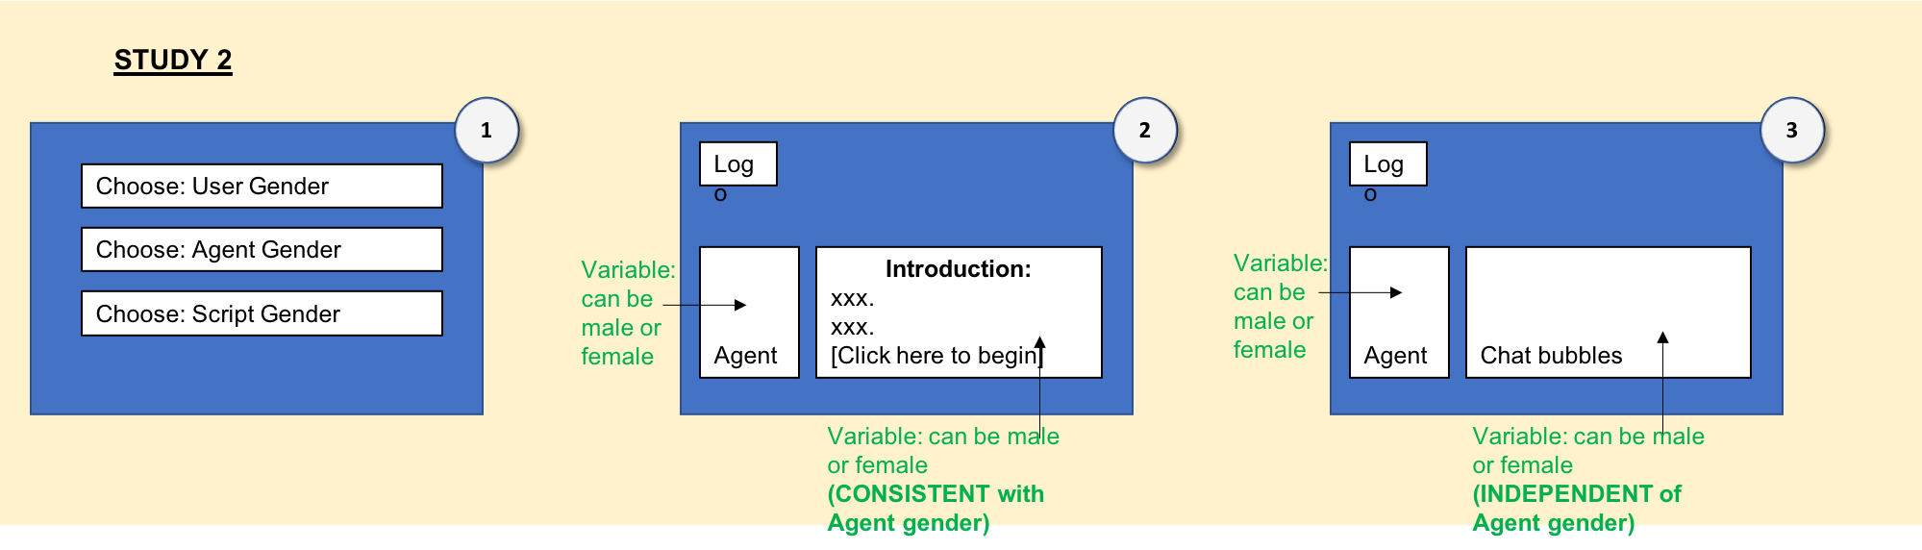

Figure: Diagram to represent flow of study 2

**ONLINE PILOT STUDY:**

***Objective:***

The objective of the pilot study is to test that my manipulations work as desired (e.g. experiment participants will perceive the male script to sound like a male)

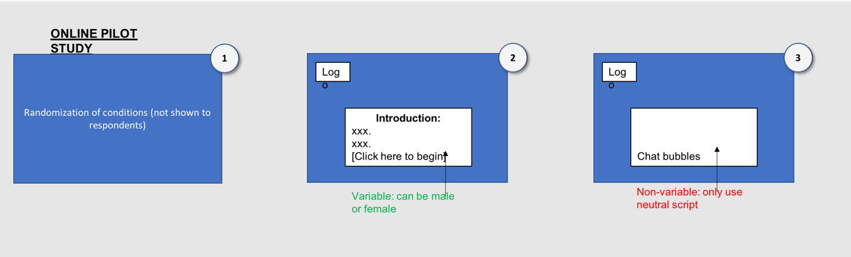

Figure: Diagram to represent flow of online pilot study

(Please refer to the PPT document for mock ups of the pages)